Public Community Member Distribution
Review

Mobile UI
No. | Screenshot | Review
1. |  | - Chips: no rotation, horizontal padding 30  - Reference:  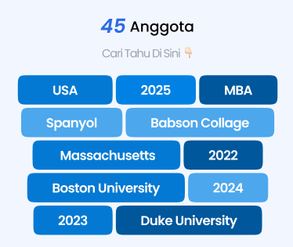
2. | 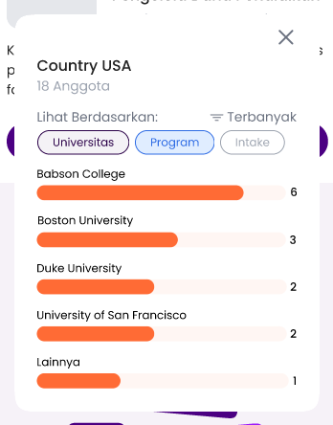 | - Background belakang modal dark sedikit transparan  - Warna chosen chip mengikuti warna tema  - Warna bar mengikuti warna tema

PC UI
No. | Screenshot | Review
1. |  | - Chips: no rotate, height 150, horizontal padding 30, size letter Ag Semi Bold 32/12, jarak antar chips seperti versi mobile  - Referensi:  
2. |  | - Background belakang modal dark sedikit transparan  - Warna chosen chip mengikuti warna tema  - Warna bar mengikuti warna tema  - Ukuran diperbesar biar balance gak kebanting

